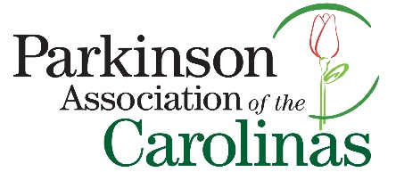

The mission of Parkinson Association of the Carolinas (PAC) is “to serve as a resource for individuals and their families affected by Parkinson’s disease in the Carolinas, through education, community outreach and direct support”.

Financial contributions and other gifts help PAC to provide important programs and services to people with Parkinson’s disease, their families and caregivers. PAC is a 501(c) (3) charitable organization and is funded solely by the generous support of individuals, corporations and foundations.

We hope you will consider making a donation to support the important work of the organization.

Donation Information
Annual Giving
□ I would like to donate $________ to support Parkinson Association of the Carolinas.
□ I would like PAC to contact me about making a recurring donation.

Honoraria or Memorial
□ I would like to make a contribution of $ _______in honor or memory of a special person. Please complete the “Make a Tribute” section on the back of this form.

Your contact information

Name: ___________________________________________________
Address: __________________________________________________
City: _____________________ State: ___________ Zip: ____________
E-mail Address: _____________________________________________
Phone: ____________________________________________________
Checks can be made payable and mailed to:
Parkinson Association of the Carolinas
PO Box 1465
Matthews, NC 28106

How would you like to receive future information about Parkinson’s disease as well as programs and services offered by PAC? □ E-mail □ Regular Mail □Please do not send me future mailings

□ Please check here if you would like your donation to remain anonymous. Your name will not appear on any public donor acknowledgement materials prepared by PAC.

Make a Tribute

PAC gladly accepts donations made to honor a family member or friend affected by Parkinson’s disease. We also accept donations made in memory of the passing of someone affected by Parkinson’s disease. An acknowledgement of your gift will be sent to you and the person or family of whom you designate below.

This gift is
In memory of: ______________________________ In honor of: ______________________________

Who should receive acknowledgement of this gift?

Name: ___________________________________________________
Address: __________________________________________________
City: _____________________ State: ___________ Zip: ____________
E-mail Address: _____________________________________________
Phone: ____________________________________________________

PO Box 1465 Matthews, NC 28106
980-245-2786 (o) 866-903-7275 (TOLL FREE)
www.parkinsonassociation.org

Federal Tax I.D. No. is 30-0064156

